Seychelles

## Respect for rule of law (ROL) data

The data set shows the data on the respect of the rule of law for the country.

## # A tibble: 19 x 5  
## country iso3c date ruleOfLaw ruleOfLawCategory4   
## <chr> <chr> <dbl> <dbl> <chr>   
## 1 Seychelles SYC 1996 0.600 ROL moderately respected   
## 2 Seychelles SYC 1998 0.345 ROL moderately respected   
## 3 Seychelles SYC 2000 0.470 ROL moderately respected   
## 4 Seychelles SYC 2002 0.323 ROL moderately respected   
## 5 Seychelles SYC 2003 0.111 ROL moderately respected   
## 6 Seychelles SYC 2004 0.162 ROL moderately respected   
## 7 Seychelles SYC 2005 0.0254 ROL moderately respected   
## 8 Seychelles SYC 2006 -0.00411 ROL moderately disrespected  
## 9 Seychelles SYC 2007 0.0988 ROL moderately respected   
## 10 Seychelles SYC 2008 0.222 ROL moderately respected   
## 11 Seychelles SYC 2009 0.0787 ROL moderately respected   
## 12 Seychelles SYC 2010 0.0313 ROL moderately respected   
## 13 Seychelles SYC 2011 -0.0116 ROL moderately disrespected  
## 14 Seychelles SYC 2012 -0.0143 ROL moderately disrespected  
## 15 Seychelles SYC 2013 0.0717 ROL moderately respected   
## 16 Seychelles SYC 2014 0.126 ROL moderately respected   
## 17 Seychelles SYC 2015 0.201 ROL moderately respected   
## 18 Seychelles SYC 2016 0.151 ROL moderately respected   
## 19 Seychelles SYC 2017 0.102 ROL moderately respected

## Respect for rule of law (ROL) trend

The plot shows the trend of the respect for the rule of law for the country.

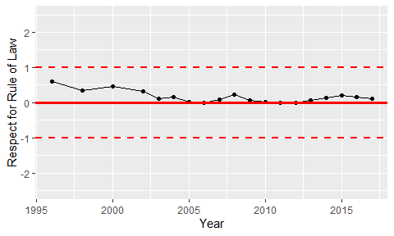

Trend of the Respect for the Rule of Law